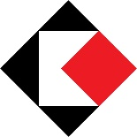 | Katonah Museum of Art  134 Jay Street  Katonah, NY 10356  914.232.9555  www.katonahmuseum.org | Press Contact:  Anna Carolan  Marketing & Comms Manager  Tel. 914.767.2975  acarolan@katonahmuseum.org
FOR IMMEDIATE RELEASE
October 14, 2026

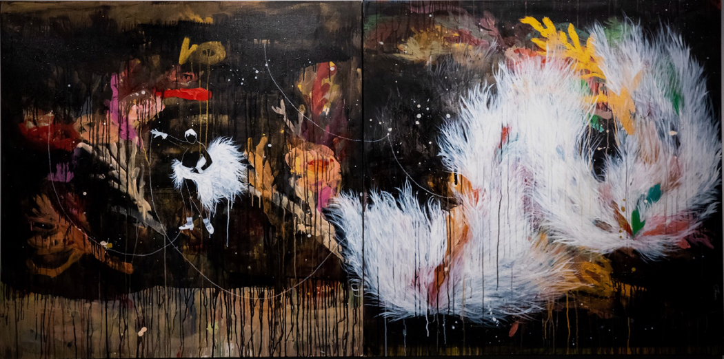

Marielle Plaisir (French and Guadeloupean, born in Le Havre, France; lives and works in Miami, FL).J. Baker, The Malediction of Cham, 2023.
Acrylic, ink, marker, and embroidery on canvas, 48 x 92 x 2 in. (121.9 x 233.7 x 5 cm).Courtesy of the artist © Marielle Plaisir Photo: MP Studio

THE KATONAH MUSEUM OF ART ANNOUNCES
FALL 2026 EXHIBITIONS
October 18, 2026–January 24, 2027

Intermittent Islands: Four Caribbean Women Artists
The Mary L. Beitzel Gallery and the Sally and Volney Righter Gallery

Sonja John: Balikbayan
The Pollack Family Learning Center

KATONAH, NY — The Katonah Museum of Art (KMA) is pleased to present Intermittent Islands: Four Caribbean Women Artists and Sonja John: Balikbayan from October 18, 2026, through January 24, 2027.

Intermittent Islands: Four Caribbean Women Artists brings together the work of four artists whose practices explore the histories, cultures, and diasporas of the Caribbean: Belkis Ayón (Cuban, 1967–1999), Yanira Collado (Dominican, born 1975 in Brooklyn, NY; lives and works in Miami, FL), Marielle Plaisir (French and Guadeloupean, born in Le Havre, France; lives and works in Miami, FL), and Lisa C Soto (Jamaican and Puerto Rican, born 1969 in Los Angeles, CA; lives and works in Ghana and Puerto Rico). Drawing on Afro-Caribbean culture and religion, the ‘canon’ of Western art, global history, and everyday life, these artists reflect upon the Caribbean as a site of place and displacement, rupture and recovery. Their practices range from figurative to abstract, incorporating painting, collage, sewing, crocheting, and layering as both formal strategies and as metaphors for connecting memories, traditions, and communities.

“The KMA is pleased to present this timely exhibition, which unites these four artists for the first time to shed light on the layered social and political history of the Caribbean and its diaspora,” says Michelle Yun Mapplethorpe, KMA Director and Chief Curator: “Through poetic reflection, their works explore cultural experiences familiar to Afro-Caribbean communities while also engaging universal questions around identity, place, and agency.”

Belkis Ayón’s collage-based prints, or collagraphs, use velvety blacks, brilliant whites, and luminous grays to depict mysterious scenes inspired by Abakuá, an Afro-Cuban secret confraternity founded in 1836. Although Abakuá is an all-male society, its founding narrative centers on the heroine Sikán, whose image Ayón uses to address universal questions of belonging and the construction of self. Combining fabric, wood, Caribbean soap, construction materials, and carbon paper, Yanira Collado layers geometric patterns into mural reliefs and sculptures, transforming ordinary things into precious objects. Like architectural fragments and sacred relics, they imply histories of loss and fracture, but also resilience and renewal. In the dreamlike paintings of Marielle Plaisir, feathery white brushstrokes are layered upon dark, dripping passages of paint, while figures such as Jackie Robinson and Josephine Baker emerge unexpectedly from the chaos around them. Her vibrant, back-lit Duratrans collages use archival images of the Caribbean to unite the colonial past with new visions of the present. Lisa C Soto creates gridded, quilt-like constructions from various metallic wires crocheted into squares and circles. As a young woman, she was taught to crochet by her grandmother, who had emigrated from Jamaica to Harlem. Draped from wall to floor and activated by small motors, the works shimmer with vital energy. Soto’s wire forms suggest intricate networks of filiation: the works are also inspired by a quilt made by one of her great-aunts and are accompanied by sounds recorded in the garden of Soto's other great aunt, who remained in Jamaica after her two sisters immigrated to the United States. More broadly, Soto’s intertwined metal threads speak to the Caribbean as a site of entangled histories.

In reckoning with the Caribbean’s complex past, these four artists intertwine the local and global, history and autobiography. Their works demonstrate how inherited histories and diasporic experiences can transform into new visual languages that speak to contemporary experiences of identity, justice, community, and belonging.

Intermittent Islands: Four Caribbean Women Artists is organized by the Katonah Museum of Art and curated by Elizabeth Monti, KMA Associate Curator.
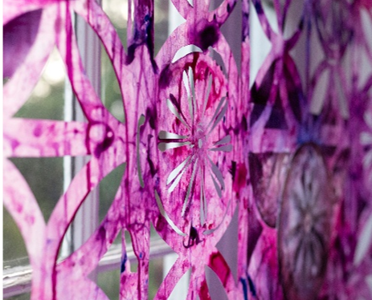
Balikbayan is a site-specific installation created for the Katonah Museum of Art by artist Sonja John (First Generation United States; Jamaican, Trinidadian, and Filipino, born 1994 in Valhalla, NY; lives and works in Bronx, NY). In her practice, John combines elements from her surroundings in New York City with recollections of her family’s places of origin; Jamaica, Trinidad & Tobago, and the Philippines. Using collage, stencils, and light, John investigates the tensions between constructed spaces and botanical forms to explore fictions of the Caribbean built from history, memory, and family archives. This installation celebrates the ingenuity of

Sonja John (First Generation United States; Jamaican, Trinidadian, and Filipino, born 1994 in Valhalla, NY; lives and works in Bronx, NY). Installation detail, Floral Larceny, 2025. Mixed media, Dimensions variable. Courtesy of the artist.
immigrant resourcefulness, reflecting the ways in which migration, the environment, agricultural practices, and cultural identity can shape our understanding of place. Visitors are invited to experience Balikbayan, experiment with a range of mixed-media art projects and interact with a collaborative light installation. The Pollack Family Learning Center transforms throughout the year with new installations, projects, and materials that extend and deepen the gallery experience.

Sonja John: Balikbayan is organized by the Katonah Museum of Art and curated by Gabrielle Blumenthal, KMA Family and Community Engagement Manager.

EXHIBITION SUPPORT

Intermittent Islands: Four Caribbean Women Artists is made possible with support from the Leir Foundation, the Jacques and Natasha Gelman Foundation, the Rosewater Family, the IFPDA Foundation, the Schultz-Williams Family, the Katherine C. and David E. Moore Exhibition Fund, and the Director’s Circle of the Katonah Museum of Art: Paul Bird and Amy Parsons, Tara and Jeffrey Coniaris, Mike Davies, Isabelle Harnoncourt Feigen, Linda Nordberg, Rebecca Samberg, and Richard and Audrey Zinman.

The Pollack Family Learning Center is made possible with support from Yvonne S. Pollack.

The Katonah Museum of Art is proud to be a grantee of the Leir Foundation, the Fred and Donna Nives Foundation, the James Rosenquist Foundation, ArtsWestchester with funding made possible by Westchester County government with support of County Executive Kenneth W. Jenkins and the Board of Legislators, and by the New York State Council on the Arts with the support of the Office of the Governor and the New York State Legislature.
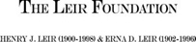
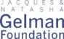

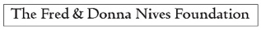



OPENING WEEKEND

First Look
October 17, 5:00 – 7:00 PM
Curator’s Circle Members and above.

Member Breakfast and Preview
October 18, 10:00 AM – 12:00 PM
All Members Welcome.

Artists in Conversation: A Panel Discussion with Yanira Collado, Marielle Plaisir, and
Lisa C Soto, moderated by KMA Associate Curator Elizabeth Monti
October 18, 12:30 – 1:30 PM
Join Intermittent Islands artists Yanira Collado, Marielle Plaisir, and Lisa C Soto for an inspiring panel discussion exploring their creative practices, artistic influences, and the ideas that shape their work. Gain unique perspectives from these accomplished artists as they engage in a dynamic conversation about contemporary art, identity, and storytelling.

PUBLIC PROGRAMS

Educator Preview with Artist Sonja John
October 28, 4:30 – 6:00 PM
Preview the KMA’s fall exhibitions with a guided tour and workshop for educators. Sonja John, whose site-specific installation Balikbayan is on view in The Pollack Family Learning Center, will discuss her artistic process and lead a creative stencil project.

Open Studio
Saturdays, 10:00 AM – 12:00 PM
Stop by each week for fresh art activities including printmaking, wire sculpture, mixed-media collage, and more. Look out for special projects on Halloween and during the Westchester Book Festival.

School’s Out / Art’s In
November 3, 11, 27, December 28, 29, 30, 31, January 18
Workshops at 10:00 AM, 11:30 AM and 1:00 PM.
Make a mess with us! Our school vacation workshops introduce mixed-media art creations, inspired by the artworks on view. From weaving wire and printmaking to image layering and mixed-media collage, each day will offer new creative experiences for little artists.

Westchester Book Festival: Phylisha Villanueva
November 7, 3:00 – 5:00 PM
Phylisha Villanueva, Westchester County Poet Laureate, leads participants in a poetry writing
workshop in response to the works on view. The workshop will conclude with a public poetry reading at 4:30 PM.

Curators in Conversation: Edward J. Sullivan, Helen Gould Shepard Professor in the History of Art; the Institute of Fine Arts and Department of Art History, NYU
November 8, 5:00 – 6:30 PM
Join Edward Sullivan for an engaging talk exploring the powerful and evocative artwork of Belkis Ayón, one of Cuba's most celebrated contemporary artists. Discover the rich symbolism, striking visual language, and cultural significance of her groundbreaking prints while gaining fresh insights from a leading expert in Latin American art.

Family Day: Caribbean Connections
November 15, 12:00 – 3:00 PM
Inspired by the work of five artists with roots across the Caribbean region, this day of artmaking explores connections between Caribbean traditions, artistic ideas, and creative fun. Families can take part in an art workshop led by guest artist Sonja John, enjoy an energetic performance, and get creative at mixed-media art stations.

An early Inclusive Hour, 11:00 AM – 12:00 PM, designed for neurodiverse audiences, is offered to families wanting a sensory-friendly environment.

Senior Social Afternoon
November 20, 1:00 – 3:00 PM
Experience an afternoon of art, creativity, and connection. Enjoy a conversational tour of the exhibitions on view, discover colorful sketching techniques with demonstrations by the NYC Urban Sketchers, and relax with light refreshments.

KMA Studio Series: Layered Inspirations
November 21, December 12, and January 16, 3:00 – 5:00 PM
Discover something new with KMAA artist Monique Ford in this hands-on workshop series for adults. Experiment with different art materials and techniques while drawing inspiration from the Museum's current exhibition.
November 21: Gelli Plate Printmaking
December 12: Mixed-media Portraits
January 16: Experiments with Weaving

Craft & Connect: Adult Art Workshops
December 3, and January 14, 5:30 – 7:30 PM
Join us for evening workshops where adults learn new artistic techniques while enjoying some creative fun!
December 3: Layered Memories with guest artist Sonja John
January 14: Collagraph Printmaking with Master Printer Chris Shore, Center for
Contemporary Printmaking
Legacy Women: Afro-Caribbean Roots Music
January 9, 3:00 – 4:30 PM
Experience the vibrant rhythms and rich musical traditions of the Afro-Caribbean diaspora with a special performance by Legacy Women. This event is co-organized with ArtsWestchester as part of the Westchester Roots series.

Presented by:

Docent–Led Tours at the KMA
Every Wednesday – Sunday, 2:30 – 3:30 PM
Take an in–depth tour of current exhibitions, guided by KMA docents.

For program registration and pricing, visit katonahmuseum.org

ABOUT THE KATONAH MUSEUM OF ART

The Katonah Museum of Art (KMA) is a non-collecting institution recognized for its innovative
exhibition and education initiatives that champion art and artists—past and present—across artistic disciplines, geographies, and historical periods. Housed in a modernist building designed by architect Edward Larrabee Barnes, the KMA was established in 1954 with a mission to spotlight exceptional art, while also responding to the most critical issues of our time through a bold and vigorous lens.

Museum hours: Wednesday – Friday and Sunday 12:00 – 5:00 PM;
Saturday 10:00 AM – 5:00 PM; Closed Mondays and Tuesdays.

